HEART DISEASE SQL QUERIES
PROJECT OVERVIEW
Project Title
Heart Disease Risk Analysis & Prediction – End-to-End Healthcare Analytics
Objective
To analyze patient health indicators and identify patterns associated with the presence of heart disease, supporting clinical decision-making and preventive care strategies.
Key Questions
- Which factors are most associated with heart disease?
- How do age, cholesterol, exercise-induced angina, and vessels count affect risk?
- What patient profiles show the highest risk?

- Total number of records
SELECT COUNT(*) AS Total_Records
FROM Heart_Disease;

SELECT Heart_Disease, COUNT(*) Heart_Disease
FROM Heart_Disease
GROUP BY Heart_Disease;
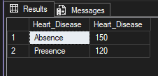

- Checking for null values
SELECT
COUNT(*) AS total_rows,
SUM(CASE WHEN Cholesterol IS NULL THEN 1 ELSE 0 END) AS missing_cholesterol,
SUM(CASE WHEN BP IS NULL THEN 1 ELSE 0 END) AS missing_bp
FROM Heart_Disease;
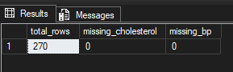
HEART DISEASE DISTRIBUTION
SELECT
Heart_Disease,
COUNT(*) AS Patient_Count,
CAST(ROUND(100.0 * COUNT(*) / SUM(COUNT(*)) OVER (), 2) AS decimal(10,2)) AS percentage
FROM Heart_Disease
GROUP BY Heart_Disease;
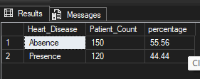
- AGE GROUP RISK ANALYSIS
SELECT
CASE
WHEN Age < 40 THEN 'Under 40'
WHEN Age BETWEEN 40 AND 49 THEN '40–49'
WHEN Age BETWEEN 50 AND 59 THEN '50–59'
ELSE '60+'
END AS age_group,
Heart_Disease, COUNT(*) AS patients
FROM Heart_Disease
GROUP BY age, Heart_Disease
ORDER BY age;
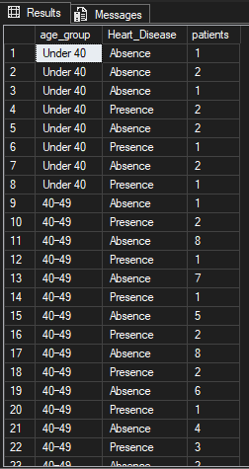
- GENDER COMPARISON
0 FEMALE, 1 MALE
SELECT
Sex,
Heart_Disease,
COUNT(*) AS patients
FROM Heart_Disease
GROUP BY Sex, Heart_Disease;
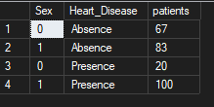

- AGGREGATION OF KEY RISK FACTORS
SELECT
Heart_Disease,
AVG(Cholesterol) AS avg_cholesterol,
AVG(BP) AS avg_bp,
AVG(Max_HR) AS avg_max_hr,
CAST(AVG(ST_depression) AS decimal(10,2)) AS avg_st_depression
FROM Heart_Disease
GROUP BY Heart_Disease;
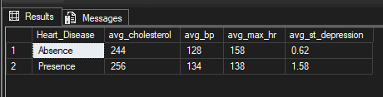
- HIGH-RISK PROFILE
SELECT *
FROM Heart_Disease
WHERE
Age > 55
AND Cholesterol > 240
AND Exercise_angina = 1
AND Number_of_vessels_fluro >= 2
AND Heart_Disease = 'Presence';
